Newsletter: Tech Tips
June 2026
Josh Chesney
iMedia Broadcast Technology Advisor - Sales Engineer

Things to know before you need it.
A few years back, I needed to have my broadcast tower inspected, and one of the things I’ve picked up working with tower rigging companies is that there is some information that you should have ready in hand. In this case, it was the location of the tower, the 911 lot number, and the location of the nearest hospital emergency room or urgent care unit. Riggers need these details before they climb, so if something goes wrong, time isn’t wasted looking for it.
Going “Off-Air” is an unfortunate hazard of the business, but there are things you can do today to limit your stations’ downtime. This article is the first of a yet-to-be-named series.
For starters, it’s knowing where to get the help you need, before you need it.
A simple list of names and contact information for your support staff, IF you have them, and the vendors you purchase your hardware and software from.
For my station
Call Letters: CIXX
Location: London, ON
Transmitter - Nautel - North America Toll Free: 1-877-628-8353
Model: NV5 / SN: H3#7
Audio Consoles - Wheatstone - 1-252-638-7000
L12/L8 Consoles / Blade 3 on v3.7
Radio Automation System - iMedia Software - 1-800-726-2635
Windows 10 LTSC / Version 4.3
Each vendor will have a specifics they’ll want about your station so they can look up your file. Nautel wants to know the Make/Model and Serial Number of the transmitter you’re calling about. Wheatstone will ask about the device (L12 Console, Blade 3, WheatNet Driver, firmware etc.) At iMedia we’ll ask you for your OS version, module application (On-Air, LogTools, Logger, etc) and version number.
My list is more of a file, and it goes on for pages. It includes all kinds of details like preferred computer hardware vendor, configuration details for getting Artist/Song Title metadata to web/RDS, and contact info for people who are smarter and more experienced than I am. If there’s a fail point, I’ve tried to document it, not just for my own sake but for the person who follows after me.
Having a contact list like the example above at hand (posted in the studio, rackroom or as a note on your phone) will save you time in an off-air emergency, but also if you’re calling for something less than mission-critical.
Continuing the How-To tradition, below is a walk-through for getting our support people connected remotely to your automation systems using TeamViewer. It’s not for everyone. If you’ve connected with us recently, are a veteran support person or engineer, jump ahead to our housekeeping piece. But if it’s been awhile, or your station doesn’t have dedicated support staff, this is for you.
Download the latest version of TeamViewer QS from our website here. Once the download is complete, move it from your downloads folder to the desktop of your automation workstation(s). When you need us to remote in, run it. We’ll ask for the session ID and password when it’s time to connect.
Please note if your station is running on EOL (End-of-Life) Operating Systems like Windows 7 and matching hardware, you’ll need a legacy version of TeamViewer 15.XX
You can download it from TeamViewer’s site here. The latest version from our site isn’t compatible with legacy systems and won’t launch.
Below are more details on getting TeamViewer up and running if and when you need it.
In a browser of your choice (ideally Firefox, Chrome, or Edge), visit our website.
www.imedia.software and from the navigation menu, click “Support”
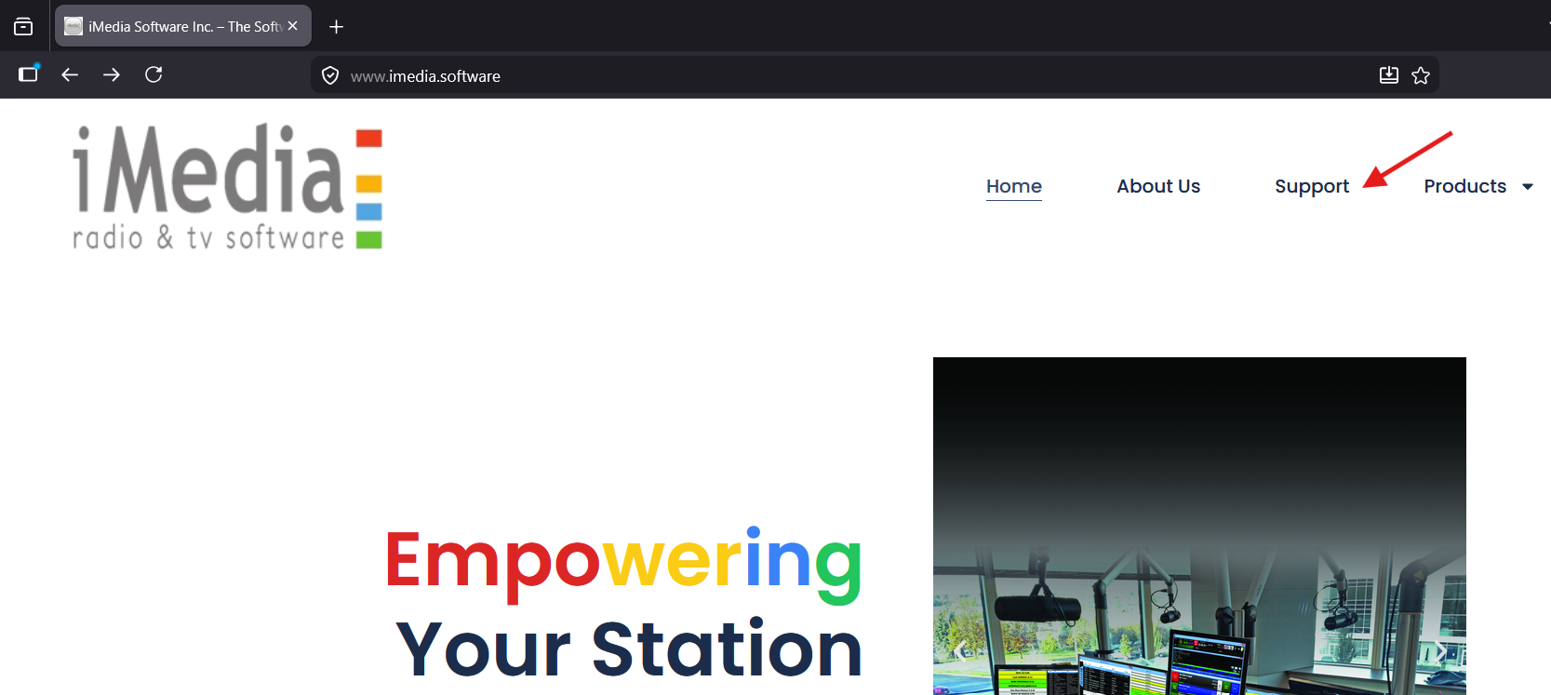
Scroll down ‘til you see, just above the “Our Plan Options” heading
Click the “iMedia -TeamViewer Remote Support” button
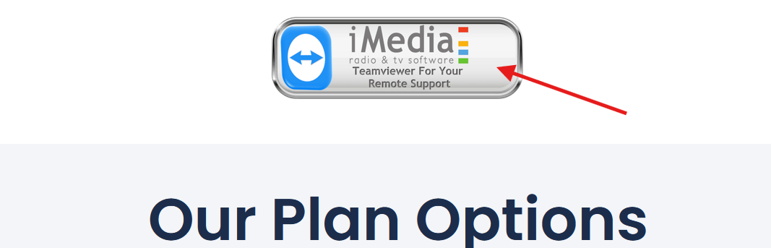

The download should start immediately, once completed go to your downloads folder


Copy or Move “TeamViewerQS” to your Desktop
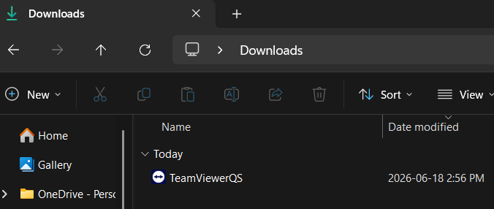
Double-click “TeamViewerQS”
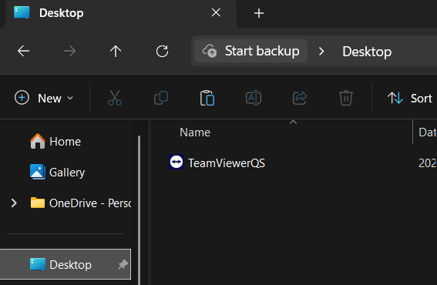
Check-off the EULA and DPA approvals when prompted
Your user ID should be 9 to 10 digits, and the password generated will be unique to that session.
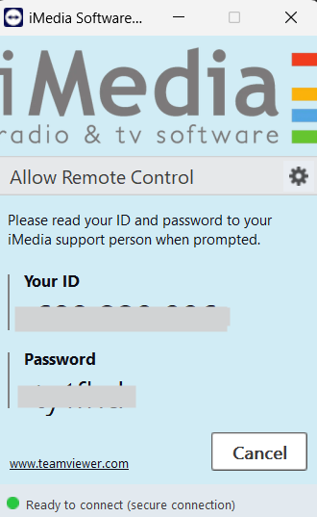
If your workstation/server needs to be restarted, support may need you to relaunch TeamViewer and grant remote access again, and will need the new password.

House Keeping
Hello IT, have you tried turning it off and back on again?
Easily one of my favourite running gags in The IT Crowd is how Chris O'Dowd’s character Roy Trenneman answers the phone. For almost 10 years, I’ve been trying to drill this advice into the heads of broadcast students, not because I’m lazy, but because it works… until it doesn’t, but that’s another story for another newsletter.
For optimum performance of your Enterprise and version 4 automation systems, it is recommended that you plan and restart your workstations and server every 30 days. This helps release old-stuck client-server sessions, which may prevent editing and/or removing old media assets from your database, as well as clear up any resource-hogging processes on your OS (Windows Update Service).
The key advice here is to plan your restarts, do them mid-week, around mid-morning if you can. I would also do this well in advance of any statutory holidays or vacations. Switch your On-Air to a backup system (Standby On-Air, VLC Playlist, CD Mix, etc.). Ideally, you’d do a full shutdown and restart of your Audio Central Server, and when it comes back up, then restart your client workstations. (On-Air, Production, and any dedicated Voice-Track and Import Systems)
IF you don’t have a standby audio procedure, now's as good a time as any to create one, but for the moment, grab an hour-long segment from your logger.
You could automate this process and schedule it for overnights/weekends, but there’s always that 1-out-of-100 chance one of your systems doesn’t come back up as expected. In future articles, I’ll get into the weeds more, but when you plan your maintenance like this, you have more control over the outcome.
Earlier in my engineering career, I would schedule an overnight shift to do this. But found that I would end up working a double shift, or worse, I would keep putting it off.
For me, the sweet spot was doing this kind of work during a voice-tracked midday shift.
It would give me a chance to run a vacuum, wipe down the tabletops and dust the equipment in the control room.
Which reminds me, I should probably give my control rooms a quick cleaning and restart my mission-critical systems.

About the Author
Josh Chesney is a +20-year broadcast veteran and has been the Senior Technologist at Fanshawe College in London, ON, Canada for the last decade. Responsible for the campus radio station CIXX-FM 106.9 The X and the supporting studios, classrooms and lab spaces for Radio and Journalism programs. Early in his career, he was the “young guy” who knew about computers, and eventually, made the jump from producer and weekend jock to engineering and on up to Chief Engineer and Director of IT.

