Newsletter: Tech Tips
July 2026
Josh Chesney
iMedia Broadcast Technology Advisor - Sales Engineer
Automate your reboots.
It’s annoying how often a simple restart of your computer systems solves the problem you’re having.
Shortly after joining CIXX and coming back to an iMediaTouch plant, one of our students swore up and down that they had put a spot into the system, but it errored out on playback. I did all the basic troubleshooting, deleting the asset, reimporting, putting on a new Cut-ID, nothing.
I could see it and listen to the asset in MT Production, but it would not playback On-Air. Support: “When was the last time you restarted your server?”
Much more recently, I’ve taken a few calls on the support line with the same story: “We had issues yesterday with the stuff that we imported into production, wasn't showing up in the On-Air [..]” The solution: reboot the server; it clears out old, frozen or locked server-client connections that cause things to be hinky.
As a broadcast engineer and geek, if you can automate a task, it’s just satisfying.
Below are step-by-step instructions for setting this up using Windows Task Scheduler.
I recommend creating one for your Central Audio Server, if you have that, and another task for your On-Air Workstation that runs 30-minutes to an hour after your Central Server restarts and comes back up.
IMPORTANT: YOU WILL GO OFF THE AIR!
If your On-Air grabs its audio from a Central Server, the On-Air won’t be able to see the server until it comes back up online. If you’re restarting your On-Air Workstation, this will cause dead air too.
***Please note iMedia Software is not responsible for any downtime or damage to equipment***

That’s it for this one.
Automating Workstation Reboots
Launch "Task Scheduler"
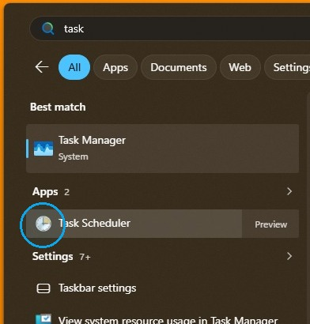
Click "Create Basic Task..." in Actions pane
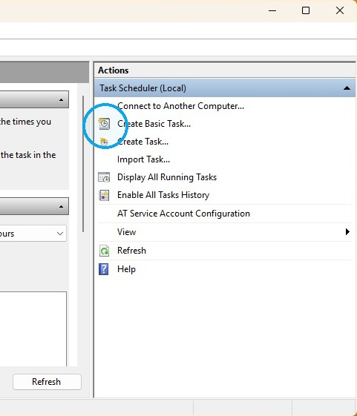
Give your task a name it
eg "AutoReboot"
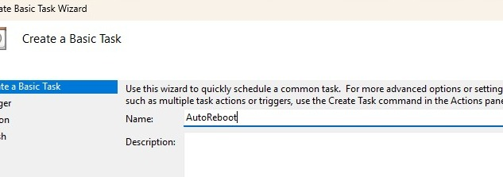
Add a description (eg Monthly Scheduled Restart)
Click "Next"
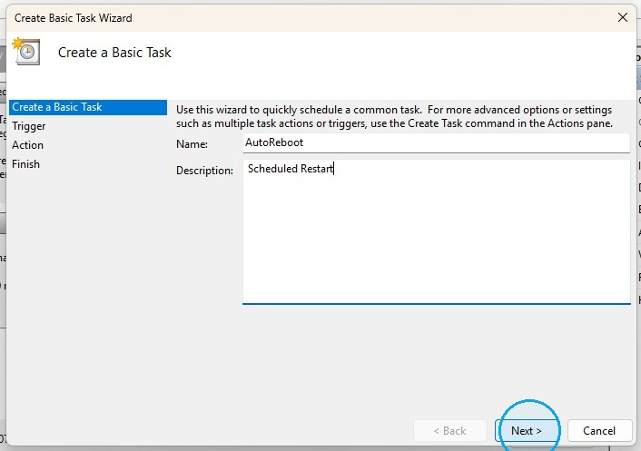
Select "Monthly"
Click "Next"
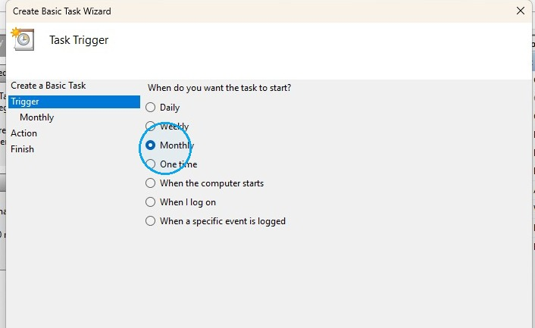
Set the start time you want the task to run
(eg 3:00:00 AM)
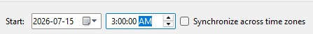
Click "Select all Months" from the 'Months drop down menu
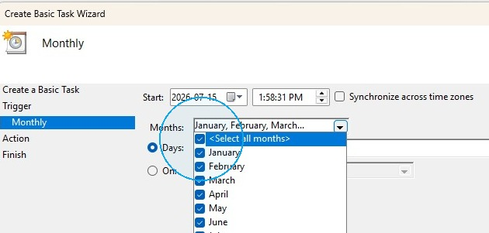
Click 'On'
Select when you which week of the month you want the task to run
(eg on the 'Third' week)
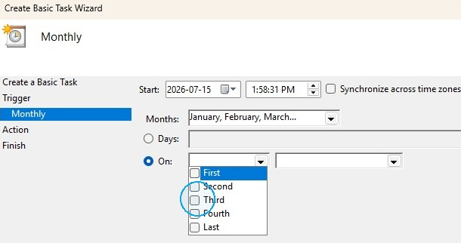
Select when you which day of that week you want the task to run
(eg on the third 'Saturday')
Click 'Next'
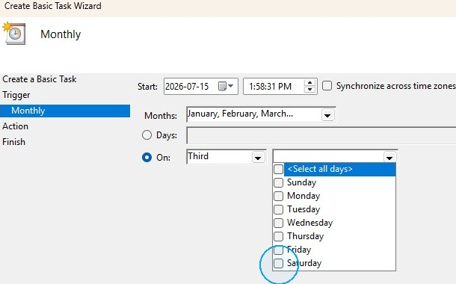
Action Settings
Select "Start a program"
Click "Next"
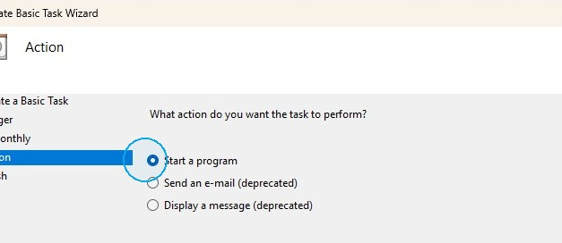
Type "shutdown" in Program/script field
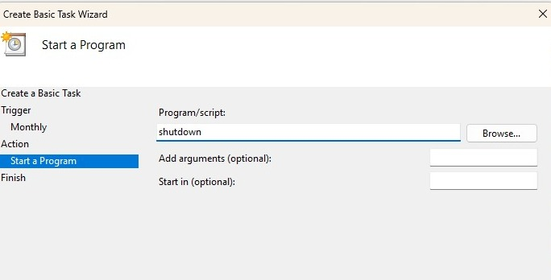
Add "/r" in arguments field, this is the restart command.
Type "/f" after if you want to force the restart, and "/t 0" to restart immediately
Click "Next"
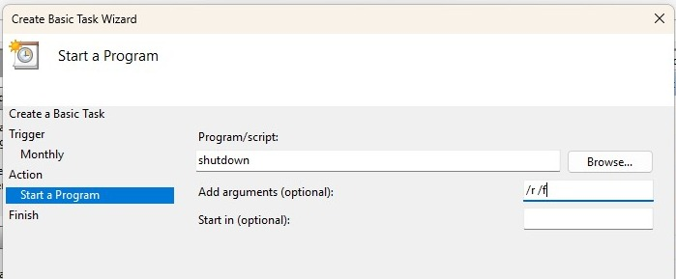
Check off "Open the Properties dialog..."
Click "Finish" to create the task
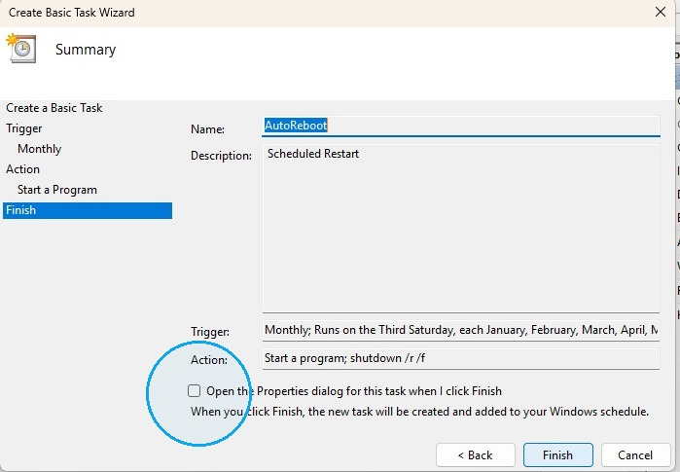
Select "Run whether user is logged on or not"
Check off "Run with highest privileges"
Click "Next"
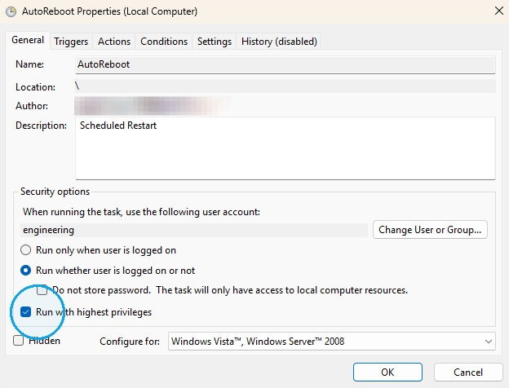
You'll be prompted for a user and password with admin privileges
Click "OK"
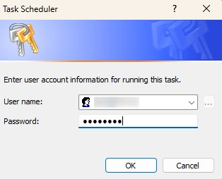
Find the your newly created task
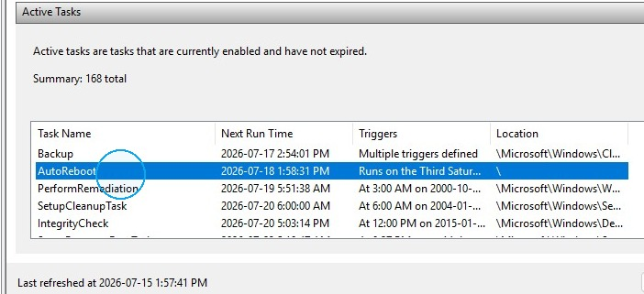
Test it
Click "Run"
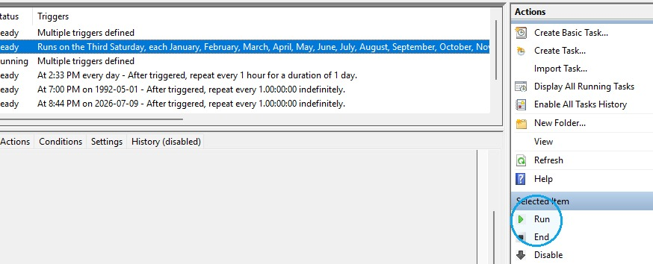
Source:
Press Win + R, type taskschd.msc, and press Enter to open Task Scheduler.
From the Action menu or right-click context menu, select Create Basic Task.
Name your task (e.g., "AutoReboot"), set your preferred recurrence (e.g., Daily or Weekly), and specify the time.
Choose Start a program as your action.
In the Program/script box, type shutdown.
In Add arguments, type /r /f (where /r restarts the PC and /f forces running programs to close).
Complete the wizard. For unattended reboots, open the task's Properties and check Run whether the user is logged on or not.

